Открытый урок по английскому языку в11-м классе по теме: "Почему люди путешествуют?"
Арустамян Л.О.учитель английского языка
Задачи:
повышать познавательный интерес к английскому языку, прививать интерес к путешествиям;
развивать способности к логическому изложению, к догадке, развивать способность осуществлять продуктивные и репродуктивные речевые действия, развивать коммуникабельность;
oвладеть лексическим материалом и расширить кругозор по теме “Путешествие”;
формировать лексические и грамматические навыки говорения, обучать умению строить высказывания по модели.
Оснащение урока:
иллюстративный материал по теме,
дидактические карточки – задания,
презентация к уроку.
Ход урока
I. Организационный момент.
- Good morning, my dear boys and girls! Good morning, dear guests!
Welcome to our lesson!
- How are you today?
- I hope you are fine. I`m OK , too.
Before we start I would like you to watch a slide to guess the topic of our lesson.
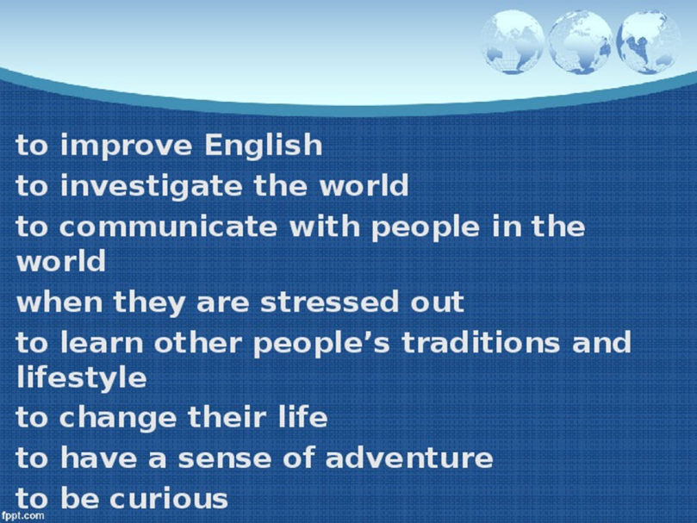

||. And now it`s time to start our lesson. The topic of our discussion today is …travelling. Right you are. Can you imagine our life without travelling? Is it possible? /ответы уч-ся/
Travelling is a part of our life. We all travel.
Why do people travel? This is the question we are going to answer at the today’s lesson. So, let’s start!
- Look at the slide. Here you can see some opinions about travelling. Read and express your own attitude towards them, please:
“I like to travel! It`s just great! Travelling helps me to change my life.
(Pupils express their opinions)

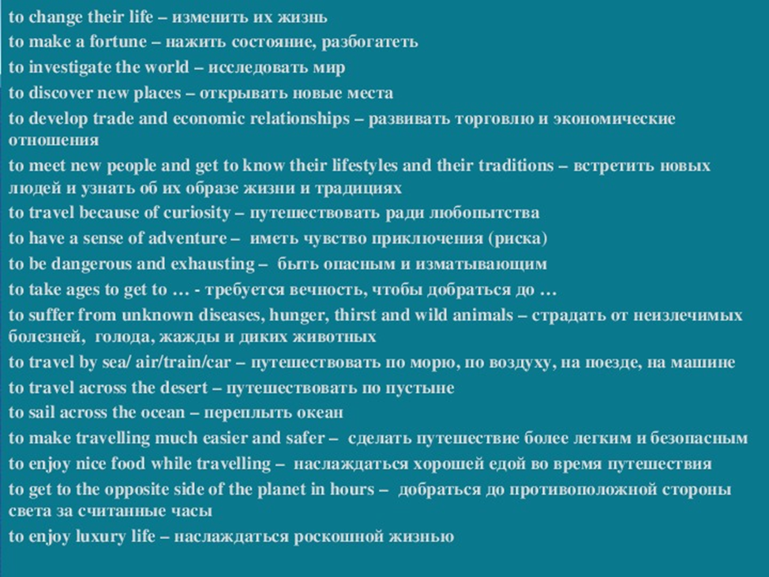

-So you see that many men – many minds.
Do you like to travel? Why do you travel? Do you believe that travelling is dangerous? Is it expensive? Is it your hobby?(Pupils answer the teacher`s questions)
III. You were asked you to write a short paragraph about the countries you want to visit. What do you know about these places? What are they famous for? While listening to each other make notes in the table.
Thank you, that’s enough. We will continue this task next lesson so keep these lists in your copybooks. But now I would like to listen to your chosen variants. Continue my phrases, please.

People like to travel ... |  | alone  with friends  with parents  with a dog  with grandparents
Usually they travel ... |  | on business  for pleasure  in search of adventures  from curiousity  to see the beauty of the world
When they travel they like to ... |  | go shopping  meet new people  make new friends  go sightseeing  learn traditions of other countries
Because travelling is ... |  | exciting  useful  fascinating  enjoyable  good for health
But sometimes it can be ... | disappointing  expensive  dangerous  troublesome  tiring
And still travelling ... | broadens our outlook  gives us life experience  leaves unforgettable impressions  helps us explore the world  allows us to understand other people better  1V  It ‘s time to have a small break. Close your eyes and imagine that you are lying on the beach. It’s sunny. The sand is warm. You hear the waves of the sea and flying seagulls. Open your eyes and look far ahead. You see a beautiful liner in the distance. Lots of people are waving you. They are happy and you happy too.  V  Now try to express your own opinion and say why people travel. All you need is to complete the  sentences in your cards.  1. Most people like to travel _____________________________________________  2. Usually they travel __________________________________________________  3. When they travel they like to __________________________________________  4. People like to travel because it is _______________________________________  5. Of course sometimes travelling can be ___________________________________  6. And still travelling __________________________________________________  It’s obvious for you that travelling has its positive and negative aspects. Let’s discuss  them with the help of “Thinking hats method”. You are divided into 3 teams.  The first team will think of factual information about  travelling and tell us why people travel. The second team will  try to identify only advantages of travelling. The third team  should think of disadvantages.( I give you 3 minutes to discuss)  V1.Now you are going to read the text about travellers and fill the table  with necessary information.  Traveller Date of birth Date of death Achievements  Marco Polo  Christopher Columbus  Vasco da Gama  Amerigo Vespucci  Vitus Bering  Ferdinand Magellan  Roald Amundsen  V11  It’s time to finish our lesson. I suppose you know why people travel and can answer this  question. I`m sure you deserve excellent marks today. Thank you for your work. Have a nice  day, my dears!  Your homework: to write a letter to your pen – friend in London telling him/her why you  like to travel.

V. Подведение итогов урока.
- It`s time to finish our lesson. I suppose you know why people travel and can answer this question. I`m sure you deserve excellent marks today. Thank you for your work. Have a nice day, my dears!
Домашнеезадание: to write a letter to your pen – friend in London telling him/her why you like to travel

